Please solve the following problem and attach to your electric motor project. You must show complete solution and answer for each question.

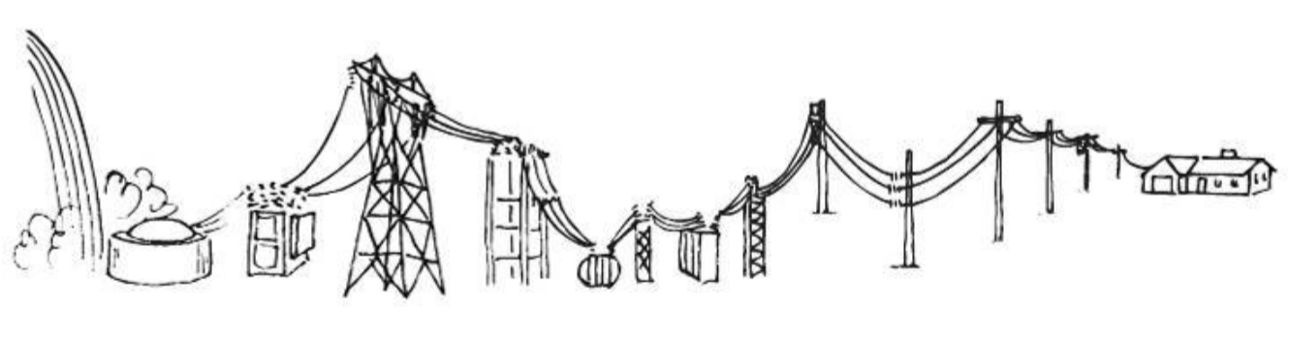

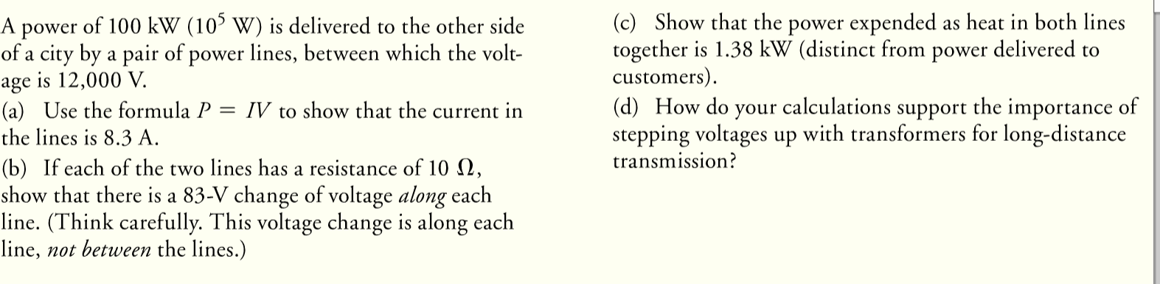

Show your solution below this line in color.

